Secondary Somatic Embryogenesis in Crocus vernus (L.) Hill
Iyyakkannu Sivanesan¹, Moon Sook Son², Sonali Jana³, and Byoung Ryong Jeong^{1,2,3*}
¹Institute of Agriculture and Life Science, Gyeongsang National University, Jinju, Korea 660-701
*Fax: + 82-55-757-7542, *E-mail: brjeong@gnu.ac.kr
²Division of Applied Life Science (BK21 Program), Graduate School, Gyeongsang National University, Jinju, Korea 660-701
³Research Institute of Life Science, Gyeongsang National University, Jinju, Korea 660-701
The authors Iyyakkannu Sivanesan and Moon Sook Son contributed equally to this work
Abstract An efficient procedure for secondary somatic embryogenesis of Crocus vernus described. The primary somatic embryos (PSE) were induced from the corm explant of C. vernus on Murashige and Skoog (MS) medium supplemented with 1.0 mg l⁻¹ 2,4- dichlorophenoxyacetic acid (2,4-D) and 0.5 mg l⁻¹ thidiazuron (TDZ) with a mean number of 52 somatic embryos per explant. The effects of medium formulations (Schenk and Hildebrandt (SH), Gamborg (B-5), Chu (N6), Anderson (AM), and MS) and light intensity (10 and 45 μmol·m⁻²·s⁻¹ photosynthetic photon flux density; PPFD) were studied for primary somatic embryo induction. The greatest number of somatic embryo induction was obtained on the SH medium amended with 1.0 mg l⁻¹ 2,4-D and 0.5 mg l⁻¹ TDZ under 10 μmol·m⁻²·s⁻¹ PPFD. The primary somatic embryos were cultured on SH medium amended with 2-isopentyl adenine or N⁶-benzyladenine (BA), in combination with α-naphthalene acetic acid (NAA) for secondary somatic embryo (SSE) induction. After 45 days, SH medium fortified with 2.0 mg l⁻¹ BA and 0.5 mg l⁻¹ NAA was found to be the best for secondary embryo induction, SSEs were induced on the surface of globular (88.9%) and heart (95.2%) PSE. At 1.0 mg l⁻¹ gibberellic acid (GA₃) 92.3% embryo maturation and conversion were observed. The highest frequency (100%) of somatic embryo conversion was obtained on SH medium supplemented with 1.0 mg l⁻¹ GA₃ and 6% (w/v) sucrose.
Keywords: corm, Dutch crocus, light intensity, plant regeneration, sucrose, thidiazuron
Introduction
The genus Crocus belongs to the family Iridaceae which includes mainly herbs with rhizomes, corms, or bulbs. It has about 80 species distributed from south-western Europe through central Europe to Turkey and south-western parts of Asia, as far as east and western China (Mathew 1982). Crocus vernus is an ornamental species, which acts as temperate forest spring ephemeral (Badri et al. 2007). It is commonly known as Dutch crocus, which originated in Russia and Eastern Europe, and is highly prized for its colorful flowers and thus used extensively in gardening. It is propagated vegetatively by daughter corms, which are formed annually at the top of the mother corm. The rate of natural propagation is very slow and the low rate of corm production limits the availability of donor material (Sivanesan et al. 2011a). Micropropagation is an alternative for large-scale production of disease-free, economically important plants. In recent years, there has been a growing interest to exploit tissue culture and genetic engineering techniques for improvement of Crocus species.
Somatic embryogenesis (SE) can be a promising technique for in vitro propagation of the plants. Moreover, secondary somatic embryogenesis (2ndSE) is a process whereby new somatic embryos are initiated from the originally-formed primary somatic embryos (PSE). It has certain advantages as compared with primary SE such as very high multiplication rate (Te-chato and Hilae 2007), independence of an explant source (Jariteh et al. 2011), and reproducibility (Karami et al. 2008). Additionally, embryogenicity can be maintained for a long period of time by repeated cycles of 2ndSE.
The induction of somatic embryos in Crocus species has been reported earlier by manipulating plant growth regulator (PGR) concentrations and subsequent use of PGR-free medium (Plessner and Ziv 1999, Karamian and Ebrahimzadeh 2001, Karamian 2007), or changes in the auxin/cytokinin ratio. Somatic embryogenesis has been accomplished for a few Crocus species viz., C. cancellatus, C. caspius, and C. michelsonii (Karamian 2004), C. heuffelianus (Demeter et al. 2010), and C. sativus (Rajabpoor et al. 2007, Sheibani et al. 2007). However, there are no reports on 2ndSE in Crocus species. The callus and organ culture of C. vernus has been previously reported by Chub et al. (1994) and SE by Sivanesan et al. (2011a). It is well known that PGRs influence somatic embryo formations. Culture conditions, medium, tissue or organ type, and its physiological status also play a pivotal role. The objective of the present study was to assess the influence of medium formulation, PGRs, and culture conditions on somatic embryo induction from corms of C. vernus, and on secondary somatic embryo (SSE) formation. Another objective was to assess the effects of gibberellic acid (GA₃) and sucrose on embryo maturation and conversion to plants.
Materials and Methods
Plant material, surface disinfestation and culture conditions
The corms were collected from the three years old greenhouse-grown plants, washed thoroughly under running tap water for 30 min, and then rinsed with distilled water. The explants were surface disinfested with 70% (v/v) ethanol (Yakuri Pure Chemicals, Japan) for 60 sec, 2.0% sodium hypochlorite (NaOCl) (Yakuri Pure Chemicals, Japan) for 10 min, and 0.01% (w/v) mercuric chloride for 15 min. Each treatment was followed by 3-4 rinses with sterile distilled water.
The medium consisted of Murashige and Skoog (MS; 1962) salts and vitamins supplemented with 3% (w/v) sucrose, and solidified with 0.8 % (w/v) agar (Plant Agar, Duchefa Biochemie, The Netherlands). The pH of the medium was adjusted to 5.7 using 0.1 N NaOH or 0.1 N HCl before autoclaving at 15 psi and 121 °C for 15 min. Gibberellic acid and thidiazuron (TDZ) were filter sterilized and added to autoclaved medium. Other PGRs were added to the medium prior to pH adjustment and disinfection.
The corms were cut into 0.5-1.0 cm long segments and cultured in 100mm Χ 40mm Petri dishes (SPL, Korea) containing MS medium supplemented with 0.25, 0.5, 1.0 or 2.0 mg l⁻¹ 2,4 dichlorophenoxyacetic acid (2,4-D) combined with 0.5 mg l⁻¹ TDZ. The explants were maintained for 14 days at 25 ± 1ºC in the dark and then exposed to light of 45 µmol·m⁻²·s⁻¹ photosynthetic photon flux density (PPFD) provided by cool white fluorescent light (40 W tubes, Philips) with a light/dark cycle of 16/8 h.
Influence of medium and light intensity on SE
The corm explants (0.5-1.0 cm) were cultured on AM (Anderson 1984), N6 (Chu et al. 1975), B-5 (Gamborg et al. 1968), MS, or SH (Schenk and Hildebrandt 1972) media amended with 1.0 mg l⁻¹ 2,4-D and 0.5 mg l⁻¹ TDZ. The two light intensities, 10 and 45 μmol·m⁻²·s⁻¹ PPFD were also tested for somatic embryo induction.
Secondary somatic embryo (SSE) induction
To obtain the secondary embryos, the PSE at different developmental stages (globular, heart and torpedo) were transferred to SH medium containing 1.0 or 2.0 mg l⁻¹ of either 2-isopentyl adenine (2-iP) or N⁶-benzyladenine (BA) combined with 0.1 or 0.5 mg l⁻¹ α-naphthalene acetic acid (NAA).
Somatic embryo maturation and conversion
Secondary somatic embryos were cultured on SH medium supplemented with acid washed activated charcoal (0.3%, w/v; C9157, Sigma-Aldrich, USA), and 0, 0.5, 1.0, 2.0 or 4.0 mg l⁻¹ GA₃ for maturation and conversion. The somatic embryos were subcultured every 3 weeks. The percentage of embryo conversion was calculated as the percentage of the number of germinated somatic embryos divided by the total number of somatic embryos.
Effect of concentration of sucrose on somatic embryo maturation and conversion
Secondary somatic embryos were cultured on SH medium supplemented with activated charcoal (0.3%, w/v), 1.0 mg l⁻¹ GA_{3,} and 0, 1.5, 3.0, 6.0 or 12.0% (w/v) sucrose for maturation and conversion. The percentage of embryo conversion was calculated as the percentage of the number of germinated somatic embryos divided by the total number of somatic embryos.
The experiments were laid out in a completely randomized design and conducted thrice. For each treatment 50 explants or embryos were used. Data were statistically analyzed by analysis of variance (ANOVA) followed by Duncan multiple range test at a 5% probability level by using SAS computer package (SAS Institute Inc., NC, USA).
Results and Discussion
In our previous study, a high frequency of SE was achieved when corm explants were cultured on MS medium with 0.5 mg l⁻¹ TDZ and 0.1 mg l⁻¹ NAA (Sivanesan et al. 2011a). However, the mean number of PSE per explant was low (8.6). 2,4-D has been proven to be the most potent auxin and effective for SE induction in many plant species (Brown et al. 1995, Balaraju et al. 2011). Thus, in the present study, we combined the previously tested TDZ (0.5 mg l⁻¹) with various concentrations of 2,4-D for somatic embryo induction. When the cultures were kept in the dark for 14 days followed by expose to light, somatic embryos formed directly on the surface the explants after 45 days at all PGRs combinations tested (Table 1). In contrast, the absence of PGRs in the culture medium the explants turned brown, and were devoid of somatic embryos. In most of the reports, a dark period of a few days has been necessary for induction of SE (Koleva-Gudeva et al. 2007, Sivanesan et al. 2011b). However, Rajabpoor et al. (2007) reported somatic embryo induction in C. sativus cultures when they were maintained completely in the dark for 70 days. Direct SE requires PGRs and favorable conditions to allow the pre-embryogenic determined cells to undergo cell divisions and expression of embryogenesis (Sharp et al. 1980). Somatic embryos at the globular, heart, and cotyledonary stages were observed throughout the incubation period on the same medium. Embryos were white or pale yellow in color, small and globular in shape appearing individually or in clusters. Morphologically, the early stage embryos appeared as shiny globular structures. None of the embryos was abnormal. In this study, all stages of somatic embryos were observed, while in C. sativus first the monopolar embryos developed, which later turned into bipolar structures during culture (Blazquez et al. 2009), and in C. heuffelianus bipolar embryos were directly differentiated from globular stage embryos (Demeter et al. 2010).
With increasing concentrations of 2,4-D from 0.25 to 1.0 mg l⁻¹, somatic embryo induction frequency and number of somatic embryos induced per explant increased, but above 1.0 mg l⁻¹ they decreased (Table 1). In contrast, high frequency of somatic embryo induction was reported in Crocus species when the culture medium was supplemented with 2.0 or 4.0 mg l⁻¹ 2,4-D in combination with 1.0 mg l⁻¹ BA (Karamian 2004, Rajabpoor et al. 2007). Thidiazuron has a dual role in the induction of SE; a cytokinin-like activity that promotes cell division and differentiation and an auxin-like activity that seems to be crucial for induction of embryogenic competence. Thus, the presence of TDZ in the culture medium may be the reason behind low concentrations of 2,4-D required for SE. Our findings are in agreement with Chen (2012) who reported that TDZ lowered the requirement of dicamba for callus induction. The SE induction was best (74.6%) at 1.0 mg l⁻¹ 2,4-D and 0.5 mg l⁻¹ TDZ on MS medium containing 3% sucrose with a mean number of 52 somatic embryos per explant (Table 1). Similarly, the combination of 2,4-D and TDZ has been used to induce SE in other plant species such as Cajanus cajan (Aboshama 2011), Pheonix dactylifera (Sidky and Zaid 2011) and Tricyrtis species (Nakano et al. 2004).
Influence of medium and light intensity on somatic embryogenesis
The frequency of SE varied significantly with the medium constitution (Table 2). Among the various media (AM, B5, MS, N6, and SH) tested, SH medium was found to be the most effective for somatic embryo induction. SH medium has low salt concentration suggesting that C. vernus has low salt requirement for the growth and SE. Of the two light intensities, somatic embryo induction was best achieved at 10 μmol m⁻² s⁻¹ PPFD as compared with 45 μmol m⁻² s⁻¹ PPFD (Fig. 1). When the cultures were maintained at 45 μmol m⁻² s⁻¹ PPFD, the mean number of somatic embryos per explant developed on MS medium and SH medium were 52.0 and 73.4, respectively. The highest frequency of somatic embryo induction (100%) was achieved when the explants were cultured on SH medium with 1.0 mg l⁻¹ l 2,4-D and 0.5 mg l⁻¹ TDZ under 10 μmol·m⁻²·s⁻¹ PPFD (Table 2). Light intensity has been reported to affect SE in terms of induction and growth of somatic embryos in Cydonia oblonga (Morini et al. 2000), Daucus carota (Takanori and Cuello 2005), and Coffea arabica (Gatica et al. 2008). Our results indicated that lower light intensities were insignificantly associated with induction and proliferation of increased number of somatic embryos. In the present study, the mean number of somatic embryos (124.7) induced per explant increased many folds than in previous reports with Crocus species (Karamian 2004, Rajabpoor et al. 2007, Demeter et al. 2010, Sivanesan et al. 2011a).
Secondary somatic embryo induction
Induction of SSEs on PSEs in SH medium with different PGR’s was carried out. After 45 days of culture, when the culture medium was supplemented with 1.0 or 2.0 mg l⁻¹ 2-iP and NAA (0.1), SSEs were not induced, but 2-iP with higher concentration of NAA (0.5 mg l⁻¹), SSEs were induced (28.6 to 62.5 embryos per PSE). The best SSE induction was achieved with 2.0 mg l⁻¹ BA and 0.5 mg l⁻¹ NAA (Table 3, Fig. 2). When PSE were transferred to this PGR combination, the highest SSE induction was achieved with heart-shaped (95.2) followed by globular PE’s (88.9). The percentage of torpedo-shaped PSEs conversion into SSEs was very low. The number of embryos induced by these PSE stages (globular, heart, and torpedo) was highest at 2.0 mg l⁻¹ BA and 0.5 mg l⁻¹ NAA (Table 3).
Effect of GA₃ on somatic embryo maturation and conversion
Somatic embryos were cultured on SH medium supplemented with 0.3% activated charcoal, GA₃ and 3% sucrose. The frequency of somatic embryo maturation and conversion were 47.1, 66.4, 92.3, 83.3 or 21.0% when SH medium was supplemented with 0, 0.5, 1.0, 2.0 or 4.0 mg l⁻¹ GA₃, respectively (Fig. 3). Thus, both the activated charcoal and GA₃ appeared to be necessary for the maturation and germination of somatic embryos. The fact that GA₃ stimulates the formation and conversion of somatic embryos is well known. Embryo maturation and simultaneous conversion to plantlets is one of the steps in SE, which partially depends on the embryo quality. In the present study, inclusion of GA₃ at higher concentrations (>2.0 mg l⁻¹) resulted in green dormant embryos with no further elongation. Contrary to this, high concentrations of GA₃ (0.75-5.79 µM) have been reported to enhance germination in wheat somatic embryos (Miroshnichenko et al. 2009). In C. heffuelianus, conversion of somatic embryos was reported by the addition of 0.5-2.0 mg l⁻¹ BA together with 2.5 mg l⁻¹ GA_{3,} 100 mg l⁻¹ ascorbic acid, and 1% sucrose (Demeter et al. 2010). In our study, activated charcoal was added to the medium to absorb the phenolics secreted by the cells. Fridborg et al. (1978) showed that activated charcoal adsorbs a number of compounds including auxins and culture metabolites which often inhibit specific developmental stages of somatic embryos. Aboshama (2011) also suggested that there was an important role of activated charcoal in reducing the inhibitory effect of residual PGRs and stimulating embryo conversion.
Effect of sucrose concentration on somatic embryo maturation and conversion
Influence of various sucrose concentrations was evaluated on embryo maturation and conversion on SH medium with 1.0 mg l⁻¹ GA₃ and 0.3 % activated charcoal. The globular embryos failed to mature in a sucrose free culture medium. When the culture medium was supplemented with 1.5, 3.0, 6.0 or 12.0%, the frequency of embryo maturation and conversion were 70.5, 92.3, 100 or 27.3, respectively. In the present study, the highest frequency (100%) of embryo conversion was achieved on SH medium with 6%. A similar result has been observed in Dianthus caryophyllus (Karami et al. 2006), and Morus alba (Agarwal et al. 2004). However, in C. heuffelianus somatic embryo maturation and germination was achived on fourfold diluted MS medium and Gamborg’s vitamins supplemented with 1% sucrose, 0.05 mg l⁻¹ NAA and 0.5 mg l⁻¹ BA (Demeter et al. 2010).
To summarize, a simple, reproducible, and efficient direct embryogenesis protocol has been standardized. In the present study, the frequency of SE was found to be influenced by concentration of PGRs, medium formulation, and light intensity. However, the results clearly indicate that low light intensity and SH medium were critical factors to achieve SSE in this Crocus species. SH medium was also found to be the best for maturation, and germination of somatic embros. No intervening callus phase was noted during somatic embryo development; hence, direct SSE induction was achieved. This technique is important, since it could be used as a possible micropropagation system and for the regeneration of transgenic plants.

Acknowledgements: “This research was supported by Technology Development Program for Agriculture and Forestry, Ministry for Food, Agriculture, Forestry and Fisheries, Republic of Korea. Project No: 109096-5”.

References
Aboshama H.M.S. (2011). Somatic embryogenesis proliferation, maturation and germination in Cajanus cajan. World Journal of Agricultural Sciences, 7: 86-95.
Agarwal S., Kanwar K., Sharma D.R. (2004). Factors affecting secondary somatic embryogenesis and embryo maturation in Morus alba L. Scientia Horticulturae, 102: 359-368.
Anderson W.C. (1984). A revised tissue culture medium for shoot multiplication of rhododendron. Journal of American Society of Horticultural Sciences, 109: 343-347.
Badri M.A, Minchin P.E.H., Lapointe L. (2007). Effects of temperature on the growth of spring ephemerals: Crocus vernus. Physiologia Plantarum, 130: 67-76.
Balaraju K., Saravanan S., Agastian P., Ignacimuthu S. (2011). A rapid system for micropropagation of Swertia chirata Buch-Ham. ex Wall.: an endangered medicinal herb via direct somatic embryogenesis. Acta Physiologiae Plantarum, 33: 1123-1133.
Blazquez S., Olmos E., Hernandez J.A., Fernandez-Garcia N., Fernandez J.A., Piqueras A. (2009). Somatic embryogenesis in saffron (Crocus sativus L.). Histological differentiation and implication of some components of the antioxidant enzymatic system. Plant Cell, Tissue and Organ Culture, 97: 49-57.
Brown D.C., Finstad K.I., Watson E.M. (1995). Somatic embryogenesis in herbaceous dicots. In: T.A. Thorpe (ed.) In vitro Embryogenesis in Plants. Kluwer Academic, The Netherlands: 345-415.
Chen J.T. (2012). Induction of petal-bearing embryos from root-derived callus of Oncidium ‘Gower Ramsey’. Acta Physiologiae Plantarum, DOI 10.1007/s11738-012-0930-1.
Chu C.C., Wang C.S., Sun C.C., Hsu C., Yin K.C., Chu C.Y. (1975). Establishment of an efficient medium for anther culture of rice, through comparative experiments on the nitrogen sources. Scientia Sinica, 18: 659-668.
Chub V.V., Vlasova T.A., Butenko R.G. (1994). Callus development and morphogenesis in generative organ culture of spring-flowering Crocus L. species. Russian Journal of Plant Physiology, 41: 815-820.
Demeter Z., Gyula Suranyi V., Molnar A., Sramko G., Beyer D., Konya Z. (2010). Somatic embryogenesis and regeneration from shoot primordia of Crocus heuffelianus. Plant Cell, Tissue and Organ Culture, 100: 349-353.
Fridborg G., Pederson M., Landstrom L.E., Eriksson T. (1978). The effect of activated charcoal on tissue cultures: adsorption of metabolites inhibiting morphogenesis. Physiologia Plantarum, 43: 104-106.
Gamborg O.L., Miller R.A., Ojima K. (1968). Nutrient requirements of suspension cultures of soybean root cells. Experimental Cell Research, 50: 148-151.
Gatica A.M., Arrieta G., Espinoza A.M. (2008). Direct somatic embryogenesis in Coffea arabica L. cvs. Caturra and Catuai: Effect of triacontanol, light condition, and medium consistency. Agronomia Costarricense, 32: 139-147.
Jariteh M., Ebrahimzadeh H., Niknam V., Vahdati K., Amiri R. (2011). Antioxidant enzymes activities during secondary somatic embryogenesis in Persian walnut (Juglans regia L.). African Journal of Biotechnology, 10: 4093-4099.
Karami O., Deljou A., Esna-Ashari M., Ostad-Ahmadi P. (2006). Effect of sucrose concentrations on somatic embryogenesis in carnation (Dianthus caryophyllus L.). Scientia Horticulturae, 110: 340-344.
Karami O., Deljou A., Karimi G. (2008). Secondary somatic embryogenesis of carnation (Dianthus caryophyllus L.). Plant Cell, Tissue and Organ Culture, 92: 273-280.
Karamian R. (2004). Plantlet regeneration via somatic embryogenesis in four species of Crocus. Acta Horticulturae, 650: 253-259.
Karamian R. (2007). Somatic embryogenesis and plant regeneration from protoplast culture of Crocus pallasii subsp. hausknechtii. Pakistan Journal of Biological Sciences, 10: 659-663.
Karamian R., Ebrahimzadeh H. (2001). Plantlet regeneration from protoplast-derived embryogenic calli of Crocus cancellatus. Plant Cell, Tissue and Organ Culture, 65: 115-121.
Koleva-Gudeva L., Spasenoski M., Trajkova F. (2007). Somatic embryogenesis in pepper anther culture: The effect of incubation treatments and different media. Scientia Horticulturae, 111: 114-119.
Mathew B. (1982). The Crocus. A revision of the genus Crocus (Iridaceae). B.T. Batsford Ltd. London, 224 pp.
Miroshnichenko D., Fillippov M., Dolgov S. (2009). Effects of daminozide on somatic embryogenesis from immature and mature embryos of wheat. Australian Journal of Crop Science, 3: 83-94.
Morini S., Onofrio C.D., Bellocchi G., Fisichella M. (2000). Effect of 2, 4-D and light quality on callus production and differentiation from in vitro cultured quince leaves. Plant Cell, Tissue and Organ Culture, 63: 47- 55.
Murashige T., Skoog F. (1962). A revised medium for rapid growth and bioassays with tobacco tissue cultures. Physiologia Plantarum, 15: 473-497.
Nakano M., Mizunashi K., Tanaka S., Godo T., Nakata M., Saito H. (2004). Somatic embryogenesis and plant regeneration from callus cultures of several species in the genus Tricyrtis. In Vitro Cellular and Development Biology Plant, 40: 274-278.
Plessner O., Ziv M. (1999). In vitro propagation and secondary metabolite production in Crocus sativus L. In: M. Negbi (ed). Saffron Crocus sativus L. Harwood Academic Publishers OPA (Overseas Publishers Association), NV 137-148.
Rajabpoor S., Azghandi A.V., Saboora A. (2007). Effects of different concentrations of 2,4-D and BAP on somatic embryogenesis induction in saffron (Crocus sativus L.). Pakistan Journal of Biological Sciences, 10: 3927-3930.
Schenk R.U., Hildebrandt A. (1972). Medium and techniques for induction and growth of monocotyledonous and dicotyledonous plant cell cultures. Canadian Journal of Botany, 50: 199-204.
Sharp W.R., Sondahl M.R., Caldas L.S., Maraffa S.B. (1980). The physiology of in vitro asexual embryogenesis. Horticultural Reviews, 2: 268-31.
Sheibani M., Azghandi A.V., Nemati S.H. (2007) Induction of somatic embryogenesis in saffron using thidiazuron (TDZ), Pakistan Journal of Biological Science, 10: 3564-3570.
Sidky R.A., Zaid Z. E. (2011). Direct production of somatic embryos and plant regeneration using TDZ and CPPU of date palm (Phoenix dactylifera L.). International Journal of Academic Research, 3: 792-796.
Sivanesan I., Lim M.Y., Jo E.H., Jeong B.R. (2011a). Somatic embryogenesis and plant regeneration in Crocus vernus. International Proceedings of Chemical Biology and Environmental Engineering, 4: 199-201.
Sivanesan I., Lim M.Y., Jeong B.R. (2011b). Somatic embryogenesis and plant regeneration from leaf and petiole explants of Campanula punctata Lam. var. rubriflora Makino. Plant Cell, Tissue and Organ Culture, 107: 365-369.
Takanori H., Cuello J. (2005). Regulating radiation quality and intensity using narrow-bands leds for optimization of somatic embryogenesis. Proceedings and Annual Meetings of American Society of Agricultural Engineers, 302-307.
Te-chato S., Hilae A. (2007). High-frequency plant regeneration through secondary somatic embryogenesis in oil palm (Elaeis guineensis Jacq. var. tenera). Journal of Agricultural Technology, 3: 345-357.
Abbreviations
2, 4-D: 2, 4-dichlorophenoxyacetic acid
2iP: 2-isopentyl adenine
AM: Anderson medium
B-5: Gamborg
BA: N⁶-benzyladenine
GA₃: Gibberellic acid
MS: Murashige and Skoog
N6: Chu
NAA: α-naphthalene acetic acid
PGR: Plant Growth Regulator
PPFD: Photosynthetic photon flux density
PSE: Primary somatic embryos
SE: Somatic embryogenesis
SH: Schenk and Hildebrandt
SSE: Secondary somatic embryo
TDZ: Thidiazuron
Table 1. Effect of concentration of 2,4-D and 0.5 mg l⁻¹ TDZ on somatic embryogenesis from corm explants of Crocus vernus cultured on the MS medium.
2,4-D (mg l⁻¹) | Somatic embryo induction (%) | No. of somatic embryos induced per explant
0.25 | 49.2±3.2d^{z} | 18.7±2.6c
0.50 | 60.8±2.5c | 30.4±3.0b
1.00 | 74.6±1.7a | 52.0±4.0a
2.00 | 69.4±1.2b | 10.2±1.6d
^{z}Means ± SD followed by the same letters within a column are not significantly different (P≤ 0.05).
Table 2. Influence of medium and light intensity on somatic embryogenesis of Crocus vernus^{z}.
Culture medium | Somatic embryo induction (%) |  | No. of somatic embryos induced per explant
Culture medium | 10 μmol m⁻² s⁻¹ PPFD | 45 μmol m⁻² s⁻¹ PPFD | 10 μmol m⁻² s⁻¹ PPFD | 45 μmol m⁻² s⁻¹ PPFD
AM^{y} | 87.4±1.6c^{x} | 60.2±1.7c | 94.7±7.4b | 66.2±2.6b
B5 | 96.4±1.4a | 72.2±1.2ab | 75.3±8.1d | 41.4±1.0d
MS | 98.2±1.7a | 74.6±2.4a | 82.4±2.7c | 52.0±2.6c
N6 | 91.8±0.5 b | 59.6±1.0c | 86.0±5.0c | 63.7±1.4b
SH | 100a | 68.0±3.1b | 124.7±9.0a | 73.4±1.0a
^{z}Corm explants were cultured on the culture medium supplemented with 1.0 mg l⁻¹ 2,4-D and 0.5 mg l⁻¹ TDZ.
^{y}AM, Anderson (1984); B5, Gamborg et al. (1968); MS, Murashige and Skoog (1962); N6, Chu et al. (1975), and SH, Schenk and Hilderbrandt (1972) medium.
^{x}Means ± SD followed by the same letters within a column are not significantly different (P≤ 0.05).
Table 3. Effect of plant growth regulators (PGRs) on secondary somatic embryogenesis (SSE) on primary somatic embryo of Crocus. vernus after 45 days of culture on SH medium.
PGRs (mg l⁻¹) |  |  | SSE induction (%) |  |  | No. of somatic embryos induced per embryo
2-iP | BA | NAA | Globular | Heart | Torpedo | Globular | Heart | Torpedo
1.0 | 0 | 0.1 | 0.0g^{z} | 0.0f | 0.0e | 0.0f | 0.0e | 0.0e
2.0 | 0 | 0.1 | 0.0g | 0.0f | 0.0e | 0.0f | 0.0e | 0.0e
1.0 | 0 | 0.5 | 32.7±0.6f | 37.5±1.6e | 28.6±0.8d | 5.7±1.5e | 4.3±2.0d | 2.3±0.5c
2.0 | 0 | 0.5 | 40.4±1.6e | 62.5±1.7d | 42.9±1.2b | 9.7±1.3d | 7.0±0.6c | 3.6±0.5b
0 | 1.0 | 0.1 | 52.3±1.8d | 60.0±2.0d | 38.1±0.5c | 11.4±1.6c | 6.2±0.4c | 1.0±0.1d
0 | 2.0 | 0.1 | 70.4±2.6b | 81.2±0.8b | 43.8±1.5b | 11.0±2.0c | 9.0±1.5b | 1.2±0.3d
0 | 1.0 | 0.5 | 67.5±3.0c | 75.0±1.0c | 40.7±1.1bc | 18.4±2.4b | 12.4±1.2ab | 4.0±0.3b
0 | 2.0 | 0.5 | 88.9±1.0a | 95.2±1.0a | 55.6±1.7a | 28.0±3.0a | 14.6±0.6a | 7.2±0.6a
^{z}Means ± SD followed by the same letters within a column are not significantly different (P≤ 0.05).

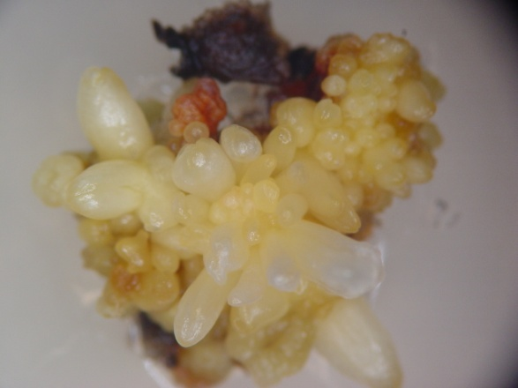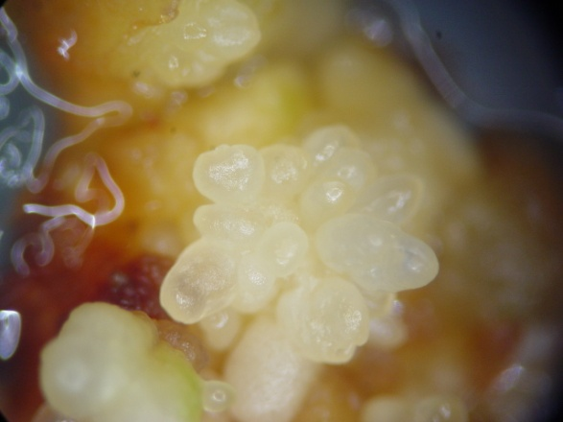
B
A
Fig. 1. Somatic embryos developed from the corm explants on Schenk and Hilderbrandt medium containing 1.0 mg l⁻¹ 2,4-D and 0.5 mg l⁻¹ TDZ after 45 days of culture under 10 μmol m⁻² s⁻¹ PPFD (A) and 45μmol m⁻² s⁻¹ PPFD (B).

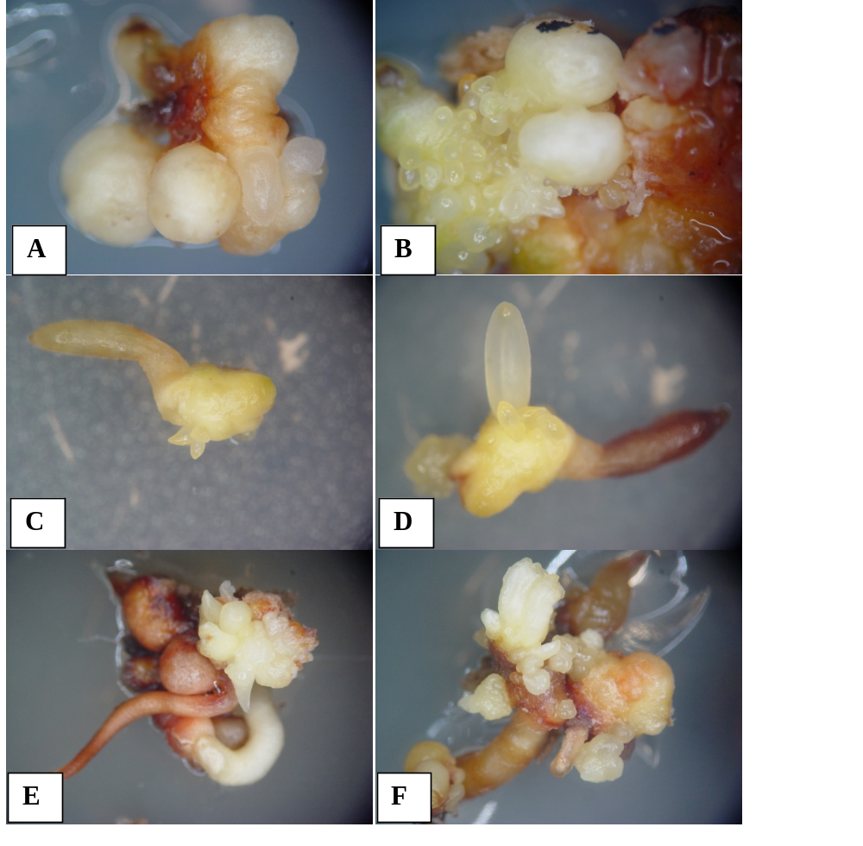
Fig. 2. Formation of secondary somatic embryos on primary embryos cultured on Schenk and Hilderbrandt medium supplemented with 2.0 mg l⁻¹ BA and 0.5 mg l⁻¹ NAA. A) Primary somatic embryos, B) secondary embryogenesis from primary somatic embryos, C, D) induction and development of secondary embryos from torpedo stage embryos, and E, F) induction and development of secondary embryos from cotyledonary stage embryos.

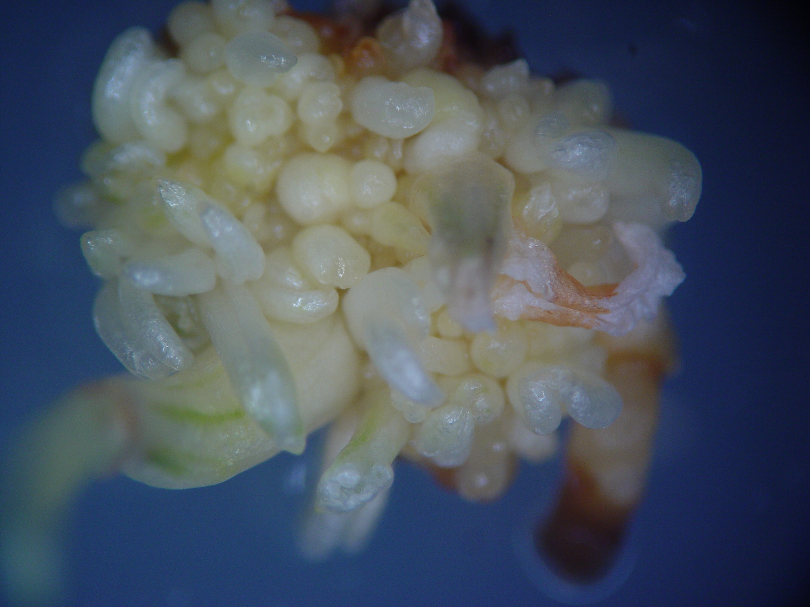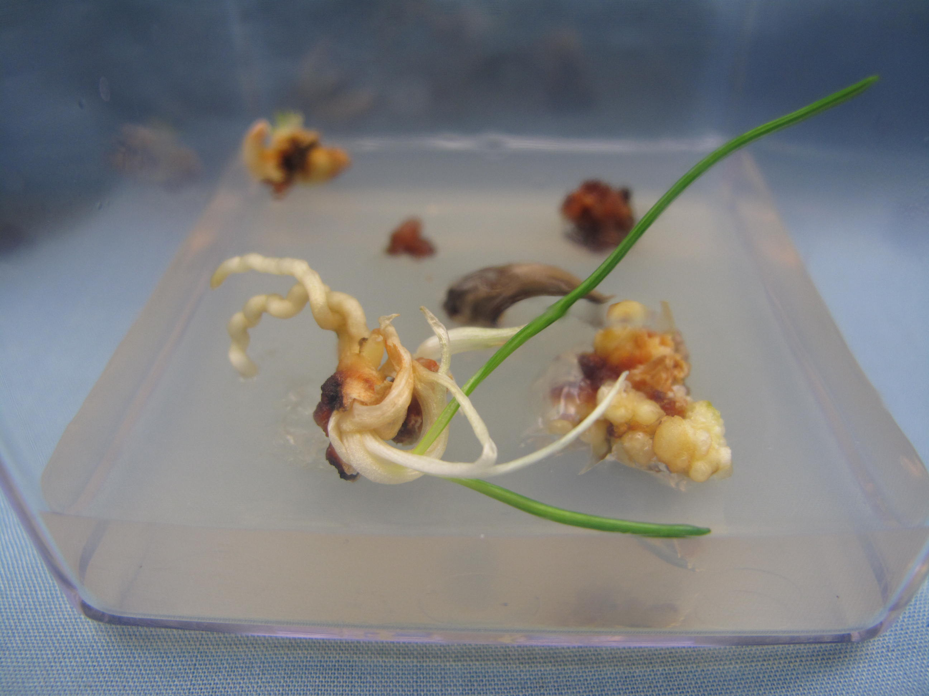
A
B

Fig.3. Maturation and conversion of somatic embryos on Schenk and Hilderbrandt medium supplemented with 6% (w/v) sucrose and 1.0 mg l⁻¹ gibberellic acid. A) germination of somatic embryos after 4 weeks and B) embryo derived plantlet

